**The Homies**

**Colin Prince**

**Duong Nguyen**

**Adil Ahmed**

**Karen Galindo Choudhary**

Our goal is to create a website which allows viewing of different statistics for cities in the United States. Examples of viewable data would be the crime index, the Quality of life indices, and the weather. The goal is to be a useful resource for people considering moving to different cities. All Data will be from 2019.

Data

Numbeo is an online resource which has a lot of the information we are looking for. We will be using it to acquire all of the data on the different measures of locations.

Crime and safety index:

<https://www.numbeo.com/crime/region_rankings.jsp?title=2019&region=021>

Quality of Life index:

[https://www.numbeo.com/quality-of-life/region_rankings.jsp?title=2019&region=](https://www.numbeo.com/quality-of-life/region_rankings.jsp?title=2019&region=021)[image.png](https://uciirvdatapt0-usy6715.slack.com/files/UU5RR0V0T/F017MU57JJU/image.png?origin_team=TTVMZKCCF&origin_channel=D0129MU9XGA)

Property Price Index:

<https://www.numbeo.com/property-investment/region_rankings.jsp?title=2019&region=021>

OpenWeatherAPI has detailed weather information on many locations.

<https://openweathermap.org/api>

Github:

<https://github.com/CPrince20/Homies>

Sketch

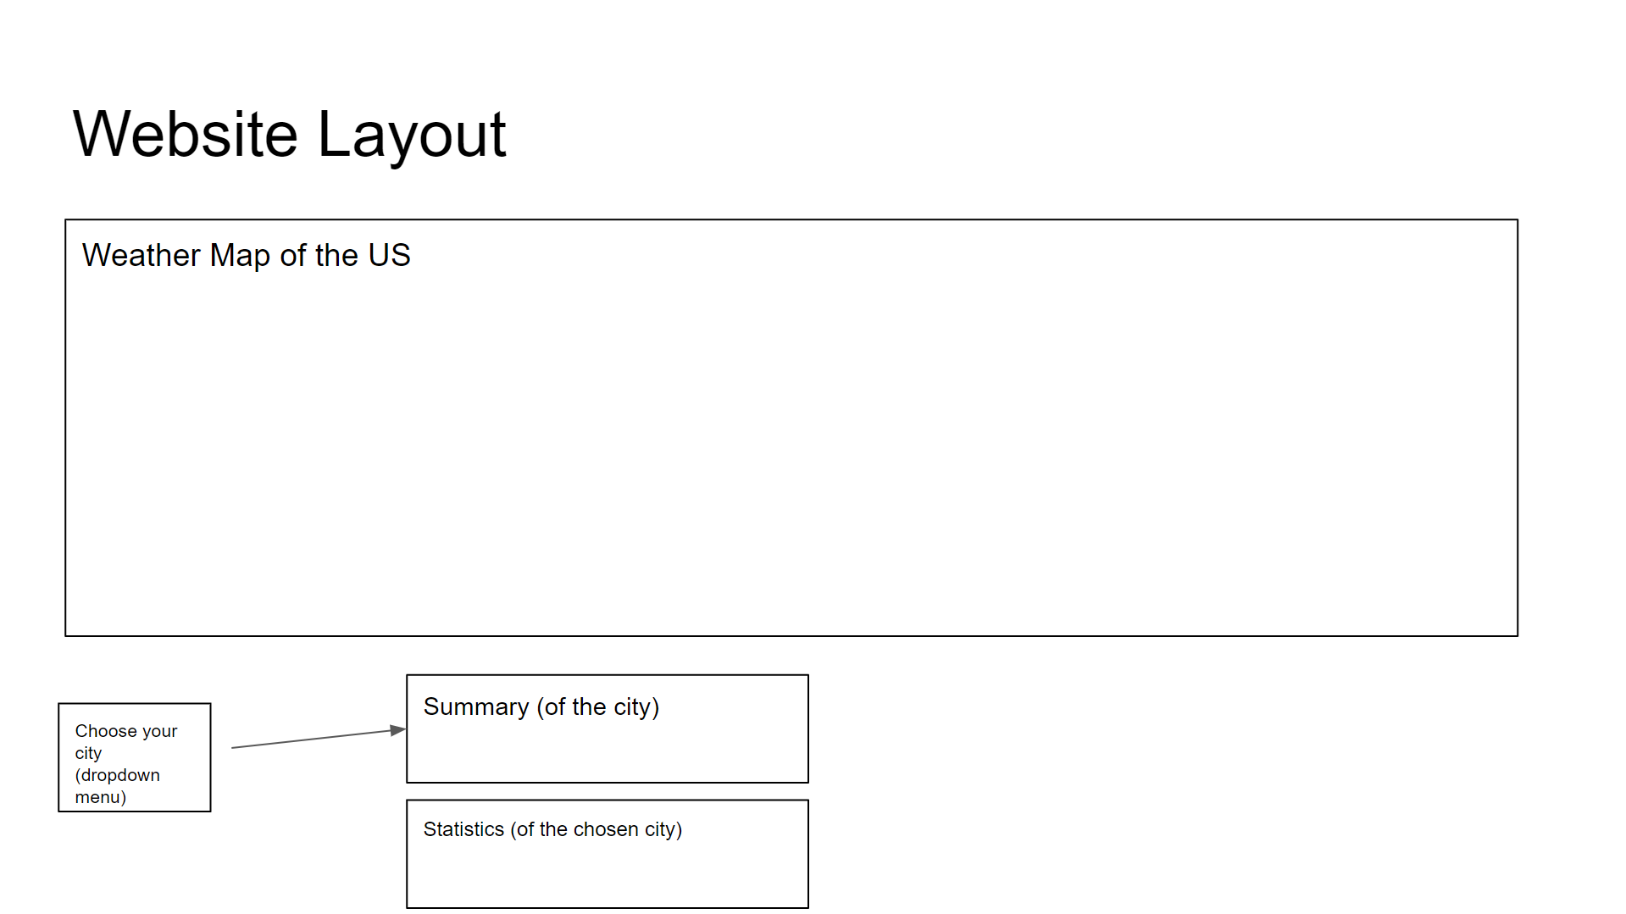

Inspiration

